**Acropolis Institute Of Technology And Research,**

**Indore(M.P.)**



**Subject – Database Management System (DBMS)**

**(CY-405)**

**Name – Atharv Mahajan Submitted To –Mrs. Nidhi Nigam**

**Enrollment No. - 0827CY233D02**

**Branch - CS(Cyber Security)**

**Semester- 4th sem**

**Index**

| **Sr.No.** | **Experiment** | **Date of Exp.** | **Date of sub.** | **Grade** |
| --- | --- | --- | --- | --- |
| 1. | To study DBMS and RDBMS, its characteristic comparisons and study of popular DB software. | 11/03/24 | 22/03/24 |  |
| 2. | To study of MYSQL, features and installation of MYSQL. | 18/03/24 | 22/04/24 |  |
| 3. | Implementation of Database commands of SQL with suitable  examples  · Create Database  · Show Database  · Use Database  · Drop Database | 24/04/24 | 1/5/24 |  |
| 4. | Implementation of DDL commands of SQL with suitable examples  · Create table  · Alter table  · Drop Table | 24/04/24 | 1/5/24 |  |
| 5. | Implementation of DML commands of SQL with suitable examples  · Insert  · Update  · Delete | 24/04/24 | 1/5/24 |  |
| 6. | Implementation of different clauses in SQL with suitable examples | 24/04/24 | 6/6/24 |  |
|  |  |  |  |  |
|  |  |  |  |  |
|  |  |  |  |  |
|  |  |  |  |  |
|  |  |  |  |  |
|  |  |  |  |  |

**What is DBMS?**

**D**atabase Management Systems (DBMS) are software systems used to store, retrieve, and run queries on data. A DBMS serves as an interface between an end-user and a database, allowing users to create, read, update, and delete data in the database.

DBMS manage the data, the database engine, and the database schema, allowing for data to be manipulated or extracted by users and other programs. This helps provide data security, data integrity, concurrency, and uniform data administration procedures.

DBMS optimizes the organization of data by following a database schema design technique called normalization, which splits a large table into smaller tables when any of its attributes have redundancy in values. DBMS offer many benefits over traditional file systems, including flexibility and a more complex backup system.

Database management systems can be classified based on a variety of criteria such as the data model, the database distribution, or user numbers. The most widely used types of DBMS software are relational, distributed, hierarchical, object-oriented, and network.

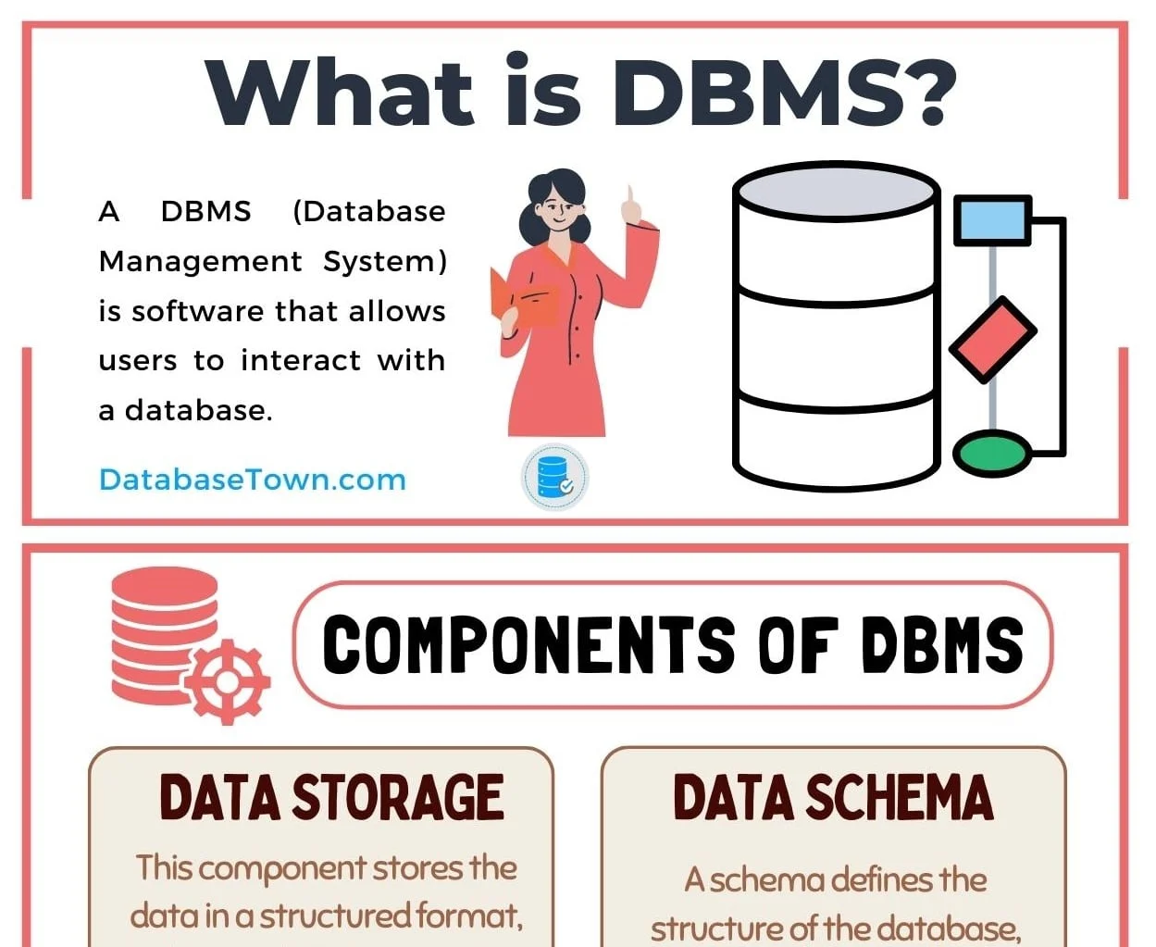

### **Distributed database management system**

A distributed DBMS is a set of logically interrelated databases distributed over a network that is managed by a centralized database application. This type of DBMS synchronizes data periodically and ensures that any change to data is universally updated in the database.

### **Hierarchical database management system**

Hierarchical databases organize model data in a tree-like structure. Data storage is either a top-down or bottom-up format and is represented using a parent-child relationship.

### **Network database management system**

The network database model addresses the need for more complex relationships by allowing each child to have multiple parents. Entities are organized in a graph that can be accessed through several paths.

### **Relational database management system**

Relational database management systems (RDBMS) are the most popular data model because of its user-friendly interface. It is based on normalizing data in the rows and columns of the tables. This is a viable option when you need a data storage system that is scalable, flexible, and able to manage lots of information.

### **Object-oriented database management system**

Object-oriented models store data in objects instead of rows and columns. It is based on object-oriented programming (OOP) that allows objects to have members such as fields, properties, and methods.

## Examples of DBMS

There is a wide range of database software solutions, including both enterprise and open source solutions, available for database management.

Here are some of the most popular database management systems:

### **Oracle**

Oracle Database is a commercial relational database management system. It utilizes enterprise-scale database technology with a robust set of features right out of the box. It can be stored in the cloud or on-premises.

### **MySQL**

MySQL is a relational database management system that is commonly used with open-source content management systems and large platforms like Facebook, Twitter, and Youtube.

### **SQL Server**

Developed by Microsoft, SQL Server is a relational database management system built on top of structured query language (SQL), a standardized programming language that allows database administrators to manage databases and query data.

| **DBMS** | **RDBMS** |
| --- | --- |
| [DBMS](https://www.geeksforgeeks.org/introduction-of-dbms-database-management-system-set-1/) stores data as file. | [RDBMS](https://www.geeksforgeeks.org/rdbms-architecture/) stores data in tabular form. |
| Data elements need to access individually. | Multiple data elements can be accessed at the same time. |
| No relationship between data. | Data is stored in the form of tables which are related to each other. |
| Normalization is not present. | Normalization is present. |
| DBMS does not support distributed database. | RDBMS supports distributed database. |
| It stores data in either a navigational or hierarchical form. | It uses a tabular structure where the headers are the column names, and the rows contain corresponding values. |
| It deals with small quantity of data. | It deals with large amount of data. |
| Data redundancy is common in this model. | Keys and indexes do not allow Data redundancy. |
| It is used for small organization and deal with small data. | It is used to handle large amount of data. |
| Not all Codd rules are satisfied. | All 12 Codd rules are satisfied. |
| Security is less | More security measures provided. |
| It supports single user. | It supports multiple users. |
| Data fetching is slower for the large amount of data. | Data fetching is fast because of relational approach. |
| The data in a DBMS is subject to low security levels with regards to data manipulation. | There exists multiple levels of data security in a RDBMS. |
| Low software and hardware necessities. | Higher software and hardware necessities. |
| Examples:[XML](https://www.geeksforgeeks.org/xml-basics/), Window Registry, Forxpro, dbaseIIIplus etc. | Examples: [MySQL](https://www.geeksforgeeks.org/architecture-of-mysql/), [PostgreSQL](https://www.geeksforgeeks.org/what-is-postgresql-introduction/), [SQL](https://www.geeksforgeeks.org/what-is-sql/) Server, Oracle, Microsoft Access etc. |

**Assignment -2**

**Aim:-**

To study of MYSQL, features and installation of MYSQL.

**What is MySQL ?**

MySQL is an open-source [**Relational Database Management System**](https://www.hostinger.com/tutorials/dbms) (RDBMS) that enables users to store, manage, and retrieve structured data efficiently. It is widely used for various applications, from small-scale projects to large-scale websites and enterprise-level solutions.

There are a few elements of MySQL. Let’s take a closer look at them:

### Database

In relation to MySQL, a database is a structured collection of data organized and stored in tables. It serves as a central repository where information is efficiently managed, allowing users to store, retrieve, update, and delete data. MySQL provides the software framework to create, maintain, and interact with these databases, making data storage and retrieval seamless and reliable.

### Client-Server Model

Computers that install and run RDBMS software are called clients. Whenever they need to access data, they connect to the RDBMS server.

MySQL is one of many RDBMS software options. RDBMS and MySQL are often thought to be the same because of MySQL’s popularity. A few [**big web applications**](https://stackshare.io/mysql) like Facebook, Twitter, YouTube, Google, and Yahoo! all use MySQL for data storage purposes. Even though it was initially created for limited usage, it is now compatible with many important computing platforms like Linux, macOS, Microsoft Windows, and Ubuntu.

### SQL

[**MySQL and SQL are not the same**](https://www.hostinger.com/tutorials/difference-between-mysql-and-sql-server). Be aware that MySQL is one of the most popular RDBMS software’s brand names, which implements a client-server model.

The client and server use a domain-specific language – Structured Query Language (SQL) to communicate in an RDBMS environment. If you ever encounter other names that have SQL in them, like **[PostgreSQL](https://www.hostinger.com/tutorials/how-to-install-postgresql-on-ubuntu/)** and Microsoft SQL server, they are most likely brands which also use Structured Query Language syntax. RDBMS software is often written in other programming languages but always uses SQL as its primary language to interact with the database. MySQL itself is written in **C** and **C++**.

SQL tells the server what to do with the data. In this case, SQL statements can instruct the server to perform certain operations:

* **Data query** – requesting specific information from the existing database.
* **Data manipulation** – adding, deleting, changing, sorting, and other operations to modify the data, the values or the visuals.
* **Data identity** – defining data types, e.g. changing numerical data to integers. This also includes defining a [**schema**](https://www.hostinger.com/tutorials/database-schema) or the relationship of each table in the database
* **Data access control** – providing security techniques to protect data. This includes deciding who can view or use any information stored in the database

### Open-Source

Open-source means that you’re free to use and modify it. You can also learn and customize the source code to better accommodate your needs. However, The GPL ([**GNU Public License**](https://www.gnu.org/licenses/gpl-3.0.en.html)) determines what you can do depending on the conditions. The commercially licensed version is available if you need more flexible ownership and advanced support.

## Why is MySQL So Popular?

MySQL is indeed not the only RDBMS on the market, but it is one of the most popular ones. The fact that many major tech giants rely on it further solidifies the well-deserved position. Here are some of the reasons.

1. **Flexible and Easy To Use**

As open-source software, you can modify the source code to suit your need and don’t need to pay anything. It includes the option for upgrading to the advanced commercial version. The installation process is relatively simple, and shouldn’t take longer than 30 minutes.

1. **High Performance**

A wide array of cluster servers backs MySQL. Whether you are storing massive amounts of big eCommerce data or doing heavy business intelligence activities, MySQL can assist you smoothly with optimum speed.

1. **An Industry Standard**

Industries have been using MySQL for years, which means that there are abundant resources for skilled developers. MySQL users can expect rapid development of the software and freelance experts willing to work for a smaller wage if they ever need them.

1. **Secure**

Your data should be your primary concern when choosing the right RDBMS software. With its Access Privilege System and User Account Management, MySQL sets the security bar high. Host-based verification and password encryption are both available.

### **Download MySQL**

Follow these steps:

**Step 1:** Go to the [official website](https://dev.mysql.com/downloads/installer/) of MySQL and download the community server edition software. Here, you will see the option to choose the Operating System, such as Windows.

**Step 2:** Next, there are two options available to download the setup. Choose the version number for the MySQL community server, which you want. If you have good internet connectivity, then choose the mysql-installer-web-community. Otherwise, choose the other one.

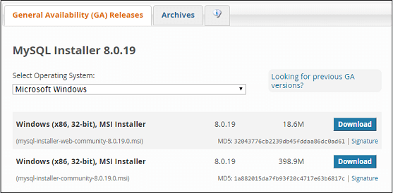

**Installing MySQL on Windows**

**Step 1:** After downloading the setup, unzip it anywhere and double click the MSI **installer .exe file.** It will give the following screen:

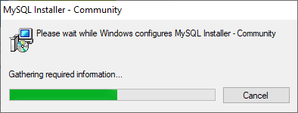

**Step 2:** In the next wizard, choose the **Setup Type**. There are several types available, and you need to choose the appropriate option to install MySQL product and [features](https://www.javatpoint.com/mysql-features). Here, we are going to select the **Full** option and click on the Next button.

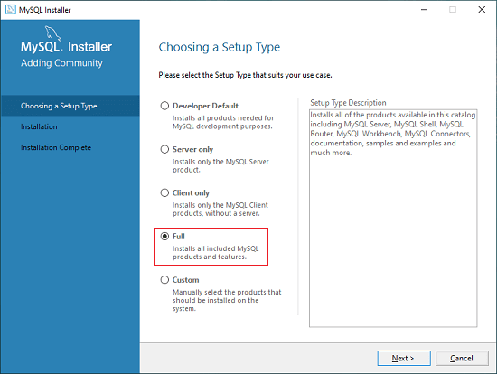

This option will install the following things: MySQL Server, MySQL Shell, MySQL Router, [MySQL Workbench](https://www.javatpoint.com/mysql-workbench), MySQL Connectors, documentation, samples and examples, and many more.

**Step 3:** Once we click on the Next button, it may give information about some features that may fail to install on your system due to a lack of requirements. We can resolve

them by clicking on the **Execute** button that will install all requirements automatically or can skip them. Now, click on the Next button.

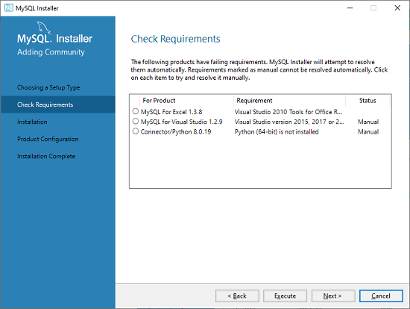

**Step 4:** In the next wizard, we will see a dialog box that asks for our confirmation of a few products not getting installed. Here, we have to click on the **Yes** button.

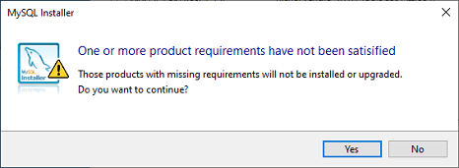

After clicking on the Yes button, we will see the list of the products which are going to be installed. So, if we need all products, click on the Execute button.

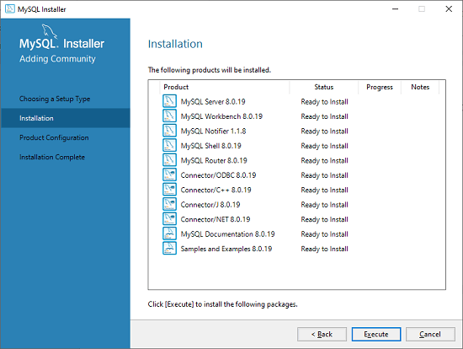

**Step 5:** Once we click on the Execute button, it will download and install all the products. After completing the installation, click on the Next button.

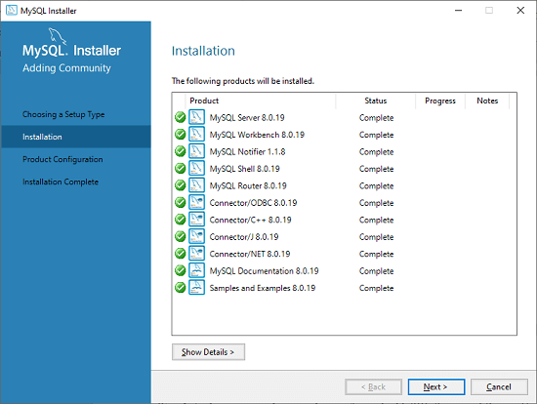

**Step 6:** In the next wizard, we need to configure the MySQL Server and Router. Here, I am not going to configure the Router because there is no need to use it with MySQL. We are going to show you how to configure the server only. Now, click on the Next button.

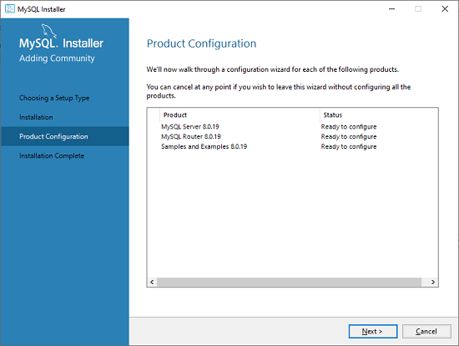

**Step 7:** As soon as you will click on the Next button, you can see the screen below. Here, we have to configure the MySQL Server. Now, choose the Standalone MySQL Server/Classic MySQL Replication option and click on Next. Here, you can also choose the InnoDB Cluster based on your needs.

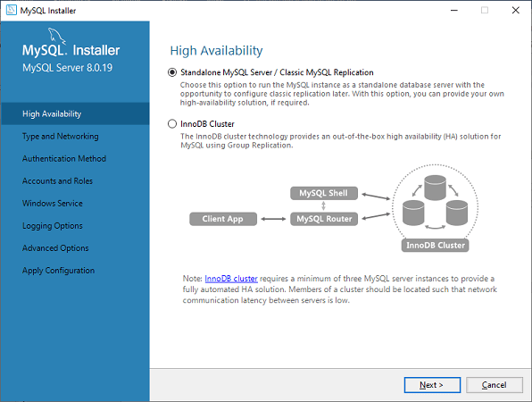

**Step 8:** In the next screen, the system will ask you to choose the Config Type and other connectivity options. Here, we are going to select the **Config Type** as 'Development Machine' and Connectivity as **TCP/IP,** and **Port Number** is 3306, then click on Next.

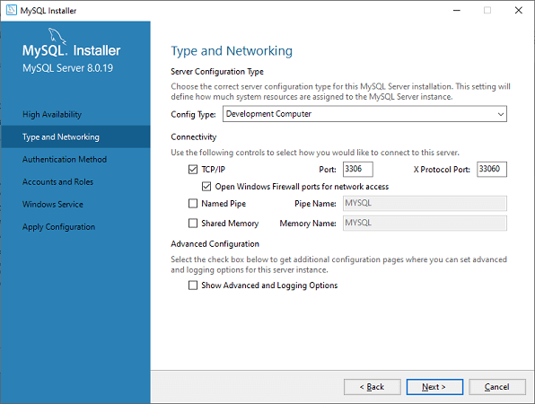

**Step 9:** Now, select the Authentication Method and click on Next. Here, I am going to select the first option.

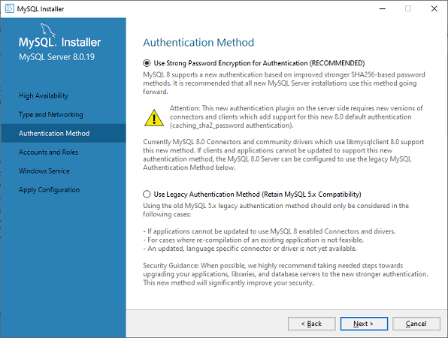

**Step 10:** The next screen will ask you to mention the MySQL Root Password. After filling the password details, click on the Next button.

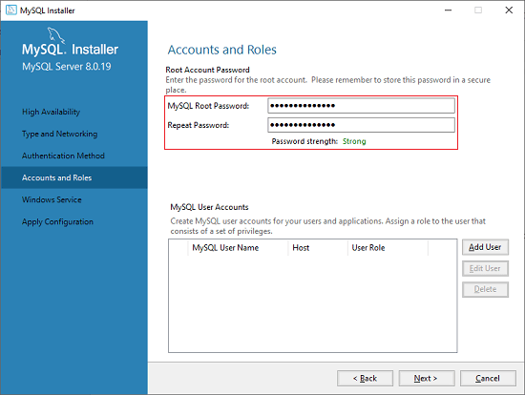

**Step 11:** The next screen will ask you to configure the Windows Service to start the server. Keep the default setup and click on the Next button.

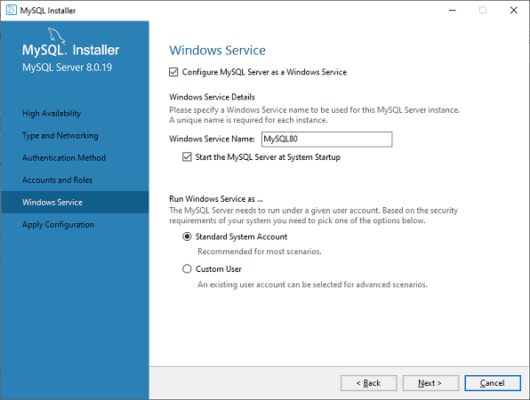

**Step 12:** In the next wizard, the system will ask you to apply the Server Configuration. If you agree with this configuration, click on the Execute button.

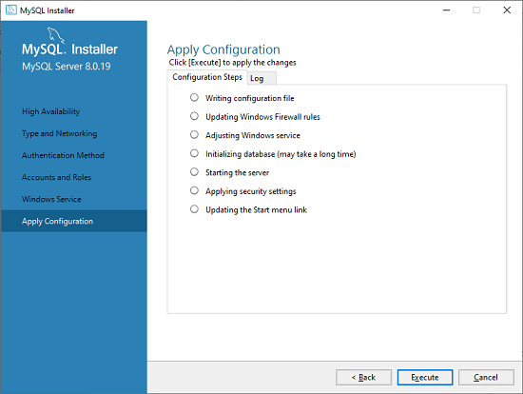

**Step 13:** Once the configuration has completed, you will get the screen below. Now, click on the **Finish** button to continue.

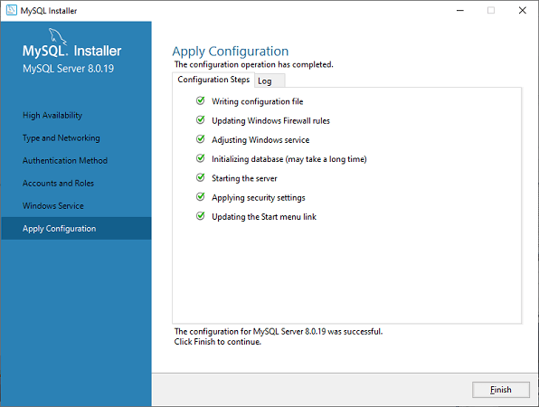

**Step 14:** In the next screen, you can see that the Product Configuration is completed. Keep the default setting and click on the Next-> Finish button to complete the MySQL package installation.

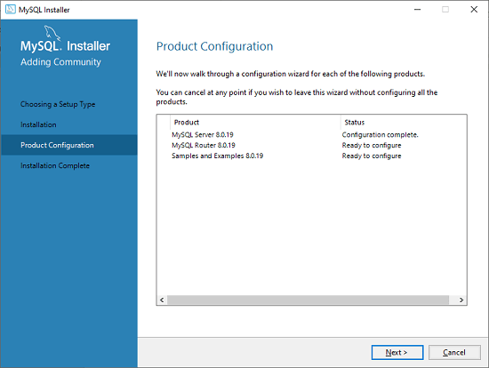

**Step 15:** In the next wizard, we can choose to configure the Router. So click on Next->Finish and then click the Next button.

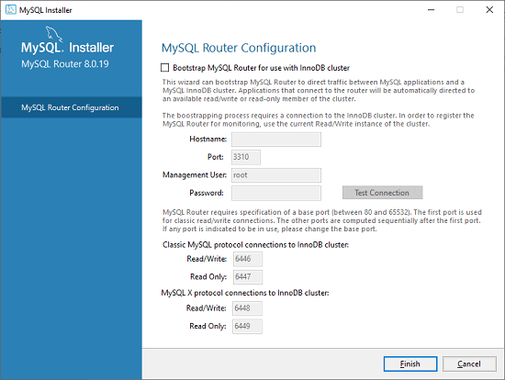

**Step 16:** In the next wizard, we will see the Connect to Server option. Here, we have to mention the root password, which we had set in the previous steps.

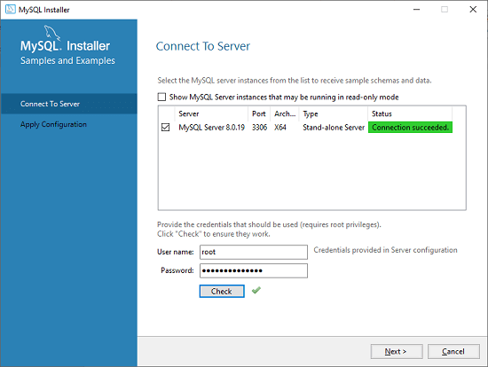

In this screen, it is also required to check about the connection is successful or not by clicking on the Check button. If the connection is successful, click on the Execute button. Now, the configuration is complete, click on Next.

**Step 17:** In the next wizard, select the applied configurations and click on the Execute button.

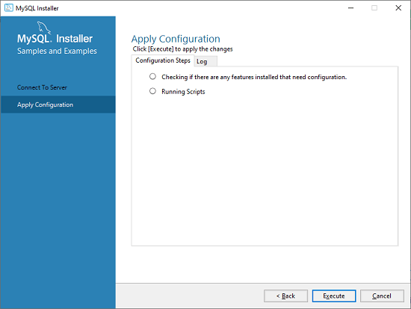

**Step 18:** After completing the above step, we will get the following screen. Here, click on the Finish button.

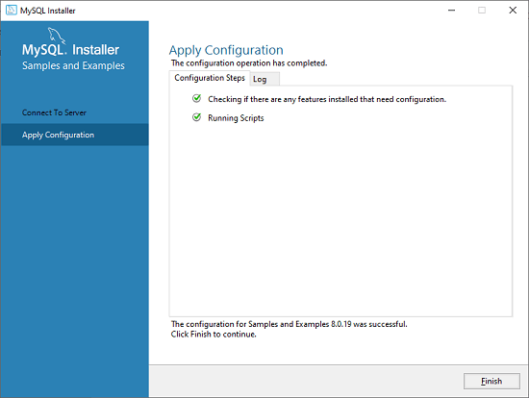

**Step 19:** Now, the MySQL installation is complete. Click on the Finish button.

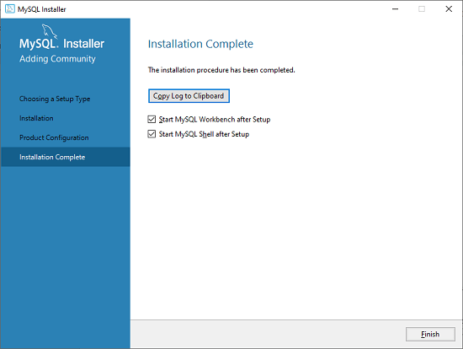

### **Verify MySQL installation**

Once MySQL has been successfully installed, the base tables have been initialized, and the server has been started, you can verify its working via some simple tests.

Open your MySQL **Command Line Client**; it should have appeared with a **mysql> prompt**. If you have set any password, write your password here. Now, you are connected to the MySQL server, and you can execute all the SQL command at mysql> prompt as follows:

**For example**: Check the already created databases with show databases command:

**Assignment-3**

**Aim-** **Implementation of Database commands of SQL with suitable**

**examples**

**· Create Database**

**· Show Database**

**· Use Database**

**· Drop Database**

• **CREATE DATABASE:** It's used to create a new database. For example, if you want to create a database named "ExampleDB", you would execute the command CREATE DATABASE ExampleDB;.

• **SHOW DATABASES:** This command lists all the databases available on the server. For example, if you want to see the list of databases on your server, you would execute the command SHOW DATABASES;.

• **USE DATABASE:** This command is used to select a specific database for subsequent operations. For example, if you want to work with the "ExampleDB" database you created earlier, you would execute the command USE ExampleDB;.

• **DROP DATABASE:** This command is used to delete a database and all its associated tables and data. For example, if you want to delete the "ExampleDB" database, you would execute the command DROP DATABASE ExampleDB;. Be very careful when using this command as it permanently deletes the database and all its data.

1. **Create Database:**



This command creates a new database named "ExampleDB".

1. Show data base

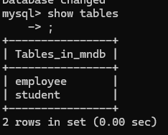

This command lists all the databases available on the server.

1. **Use Database:**



This command selects the database "ExampleDB" for subsequent operations. It's important to note that once you've selected a database using the USE statement, all subsequent SQL statements will operate on that database until you change it with another USE statement or end the session.

1. **Drop Database:**

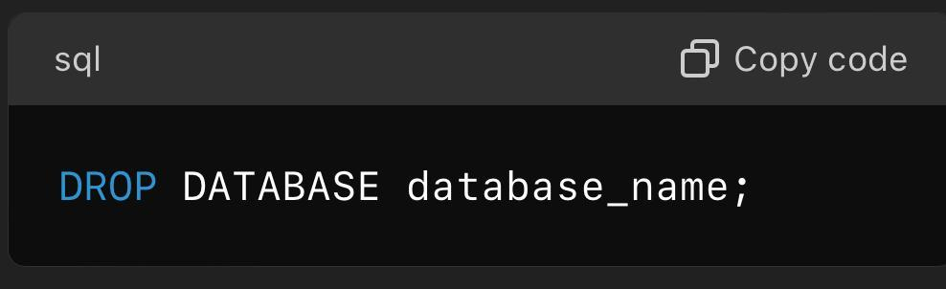

This command deletes the database "ExampleDB" along with all its tables and data. Be cautious when using this command as it irreversibly deletes the database and its contents.

Assignment-4

IMPLEMENTATION OF DDL COMMANDS OF SQL:

**DDL (Data Definition Language)**

[DDL](https://www.geeksforgeeks.org/features-of-structured-query-language-sql/) or Data Definition Language actually consists of the SQL commands that can be used to define the database schema. It simply deals with descriptions of the database schema and is used to create and modify the structure of database objects in the database. DDL is a set of SQL commands used to create, modify, and delete database structures but not data. These commands are normally not used by a general user, who should be accessing the database via an application.

List of DDL commands:

* [**CREATE**](https://www.geeksforgeeks.org/sql-create/): This command is used to create the database or its objects (like table, index, function, views, store procedure, and triggers).
* [**DROP**](https://www.geeksforgeeks.org/sql-drop-truncate/): This command is used to delete objects from the database.
* [**ALTER**](https://www.geeksforgeeks.org/sql-alter-add-drop-modify/)**:**This is used to alter the structure of the database.

**CREATE TABLE :A Table is a combination of rows and columns. For creating a table we have to define the structure of a table by adding names to columns and providing data type and size of data to be stored in columns.**

**Syntax**:

*CREATE table table_name*

*(*

*Column1 datatype (size),*

*column2 datatype (size),*

*.*

*.*

*columnN datatype(size)*

*);*

*Here****table_name****is**name of the table,****column****is the name of column.*

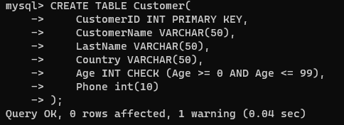

## SQL ALTER TABLE Statement

The ALTER TABLE statement is used to add, delete, or modify columns in an existing table.The ALTER TABLE statement is also used to add and drop various constraints on an existing table.

## ALTER TABLE - ADD Column

To add a column in a table, use the following syntax:

ALTER TABLE *table_name*  
ADD *column_name datatype*;

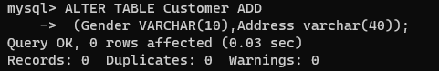

## The SQL DROP TABLE Statement

The DROP TABLE statement is used to drop an existing table in a database.

### Syntax:

DROP TABLE *table_name*;

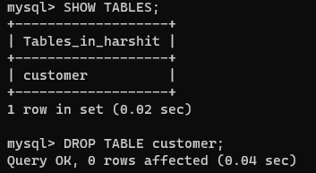

Assignment-5

IMPLEMENTATIOIN OF DML COMMANDS IN SQL:

**DML(Data Manipulation Language)**

The SQL commands that deal with the manipulation of data present in the database belong to DML or Data Manipulation Language and this includes most of the SQL statements. It is the component of the SQL statement that controls access to data and to the database. Basically, DCL statements are grouped with DML statements.

List of DML commands:

* [**INSERT**](https://www.geeksforgeeks.org/sql-insert-statement/): It is used to insert data into a table.
* [**UPDATE**](https://www.geeksforgeeks.org/sql-update-statement/)**:** It is used to update existing data within a table.
* [**DELETE**](https://www.geeksforgeeks.org/sql-delete-statement/): It is used to delete records from a database table.

### **INSERT**[**​**](https://docs.getdbt.com/terms/dml#insert) **:**

Using the INSERT DML command, you can add rows to a table that exists in your database. To be honest, data folks are rarely inserting data into tables manually with the INSERT command. Instead, data team members will most often use data that’s already been inserted by an [ELT](https://docs.getdbt.com/terms/elt) tool or other data ingestion process.

SYNTAX : **INSERT** **INTO** TABLE_NAME ( column_Name1 , column_Name2 , column_Name3 , .... column_NameN )  **VALUES** (value_1, value_2, value_3, .... value_N ) ;  

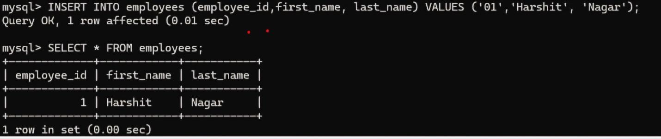

## UPDATE DML Command

UPDATE is another most important data manipulation command in Structured Query Language, which allows users to update or modify the existing data in database tables.

**Syntax of UPDATE Command:**

**UPDATE** Table_name **SET** [column_name1= value_1, ….., column_nameN = value_N] **WHERE** CONDITION;



## DELETE DML Command

DELETE is a DML command which allows SQL users to remove single or multiple existing records from the database tables.

This command of Data Manipulation Language does not delete the stored data permanently from the database. We use the WHERE clause with the DELETE command to select specific rows from the table.

**Syntax of DELETE Command**

**DELETE** **FROM** Table_Name **WHERE** condition;

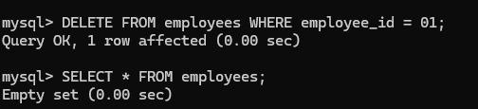

### 

Assignment-6

Implementation of different clauses in SQL with suitable examples

· Where

· Group By

· Having

· Order By

• **WHERE**:

The WHERE clause is used to filter rows based on a specified condition.

**Syntax of where clause with a select query to retrieve all the column values for every record from a table:**

1. **SELECT** * **FROM** TABLENAME **WHERE** CONDITION;

**If according to the requirement, we only want to retrieve selective columns, then we will use below syntax:**

**SELECT** COLUMNNAME1, COLUMNNAME2 **FROM** TABLENAME **WHERE** CONDITION;

• **GROUP BY**:

The GROUP BY clause is used to group rows that have the same values into summary rows, typically to perform aggregate functions like COUNT, SUM, AVG, etc.

The syntax of Group By clause:

1. **SELECT** * **FROM** TABLENAME **GROUP** **BY** COLUMNNAME;

The above syntax will select all the data or records from the table, but it will arrange all those data or records in the groups based on the column name given in the query.

The syntax of Group By clause with Aggregate Functions:

**SELECT** COLUMNNAME1, Aggregate_FUNCTION (COLUMNNAME) **FROM** TABLENAME **GROUP** **BY** COLUMNNAME;

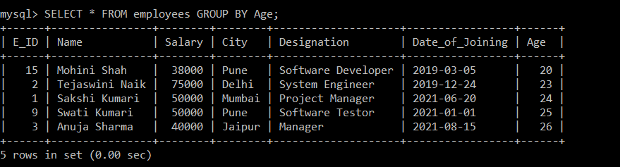

• **HAVING**:

The HAVING clause is used to filter groups of rows returned by a GROUP BY clause based on specified conditions.

### **Syntax:**

    TABLENAME **GROUP** **BY** COLUMNNAME **HAVING** CONDITION;

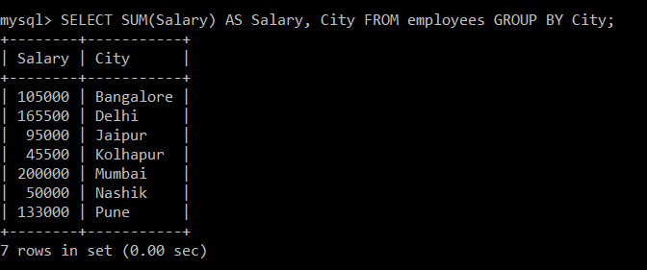

;

• **ORDER BY**:

The ORDER BY clause is used to sort the result set in ascending or descending order based on one or more columns.

### **Syntax of ORDER BY clause without asc and desc keyword:**

1. **SELECT** COLUMN_NAME1, COLUMN_NAME2 **FROM** TABLE_NAME **ORDER** **BY** COLUMNAME;

### **Syntax of ORDER BY clause to sort in ascending order:**

1. **SELECT** COLUMN_NAME1, COLUMN_NAME2 **FROM** TABLE_NAME **ORDER** **BY** COLUMN_NAME **ASC**;

### **Syntax of ORDER BY clause to sort in descending order:**

1. **SELECT** COLUMN_NAME1, COLUMN_NAME2 **FROM** TABLE_NAME **ORDER** **BY** COLUMN_NAME **DESC**;

